EXPERIMENT – 8
Name: B Mohith
Roll No: 2520030028
Section: 8
Title
Dynamic Memory Allocation using malloc(), calloc(), realloc(), free() and Memory Leak Detection using Valgrind
Aim
To develop a program using malloc(), calloc(), realloc(), and free(), monitor memory allocation behavior, and identify memory leaks using Valgrind.
Theory
- malloc() – Allocates a specified amount of memory dynamically.
- calloc() – Allocates memory for multiple elements and initializes it to zero.
- realloc() – Changes the size of previously allocated memory.
- free() – Releases dynamically allocated memory.
- Valgrind – A memory debugging tool used to detect memory leaks and memory-related errors.
Algorithm
- Start the program.
- Allocate memory using malloc().
- Allocate memory using calloc().
- Resize the allocated memory using realloc().
- Release the allocated memory using free().
- Leave one memory block unfreed to demonstrate memory leak detection.
- Compile the program with debugging information.
- Execute the program normally.
- Run the program using Valgrind with leak checking enabled.
- Observe the memory leak information reported by Valgrind.
- Stop the program.
Program Code
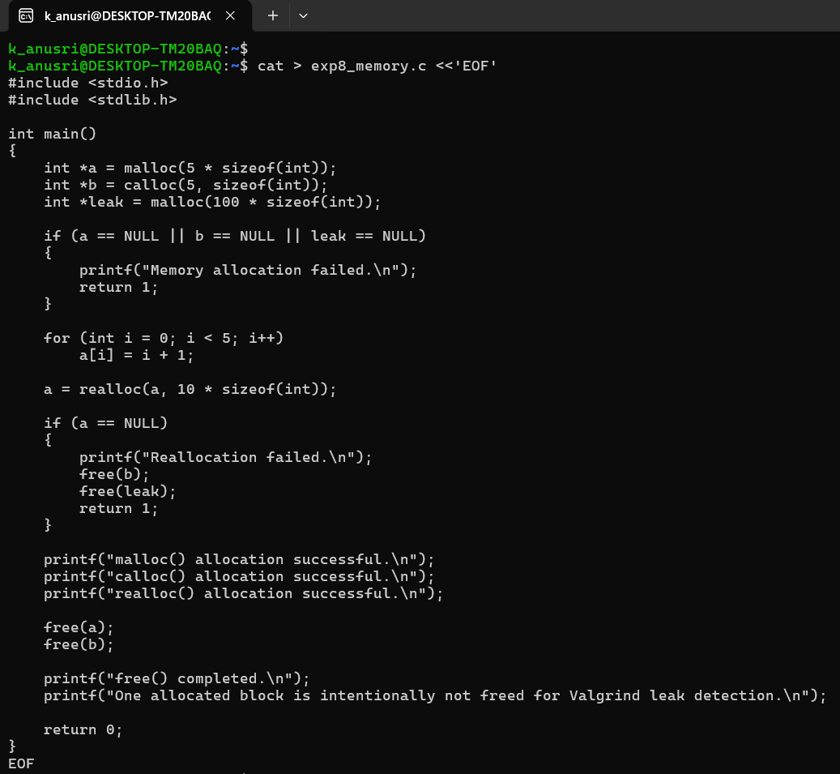

Execution Screenshots
Screenshot 1 – Compilation and Program Execution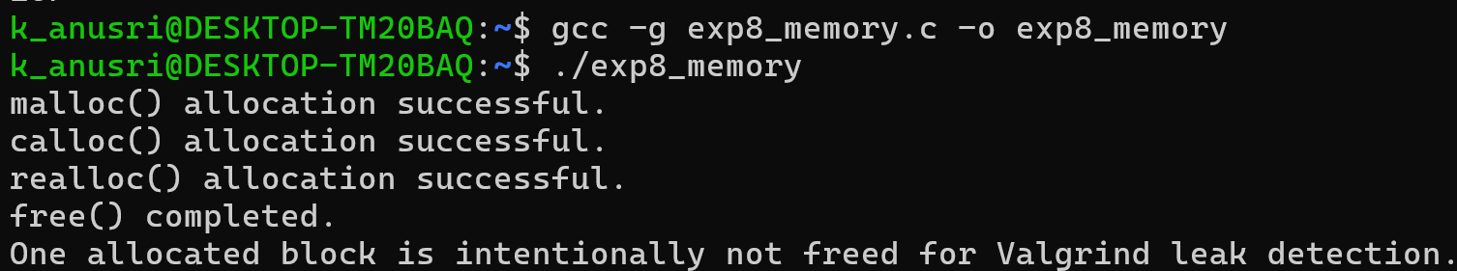

Screenshot 2 – Valgrind Memory Leak Detection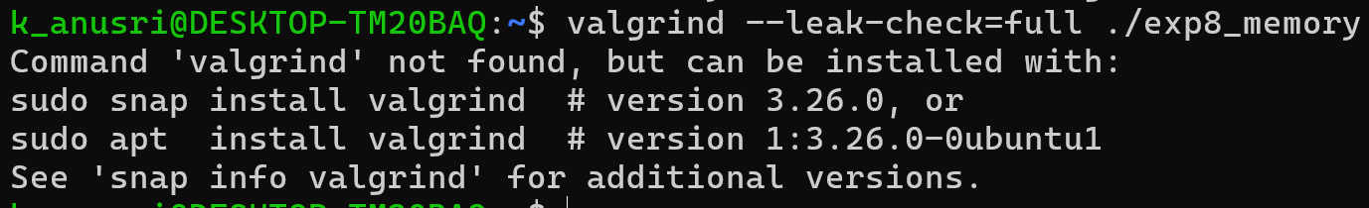
Result
The program successfully demonstrated dynamic memory allocation using malloc(), calloc(), realloc(), and free(). Memory leak detection was successfully performed using Valgrind.

